Operator Precedence
Operator precedence tells the order of execution of operator.
The following table summarizes the operator precedence in Python, from highest precedence (most binding) to lowest precedence (least binding). Operators in the same box have the same precedence. Unless the syntax is explicitly given, operators are binary. Operators in the same box group left to right (except for exponentiation and conditional expressions, which group from right to left).

Operator | Description
(expressions...),  [expressions...], {key: value...}, {expressions...} | Binding or parenthesized expression, list display, dictionary display, set display
x[index], x[index:index], x(arguments...), x.attribute | Subscription, slicing, call, attribute reference
await x | Await expression
** | Exponentiation
+x, -x, ~x | Positive, negative, bitwise NOT
*, @, /, //, % | Multiplication, matrix multiplication, division, floor division, remainder
+, - | Addition and subtraction
<<, >> | Shifts
& | Bitwise AND
^ | Bitwise XOR
| | Bitwise OR
in, not in, is, is not, <, <=, >, >=, !=, == | Comparisons, including membership tests and identity tests
not x | Boolean NOT
and | Boolean AND
or | Boolean OR
if – else | Conditional expression
lambda | Lambda expression
:= | Assignment expression

Precedence of arithmetic operators
** | Exponentiation
*,@,/,//,% | Multiplication, matrix multiplication, division, floor division, remainder
+,- | Addition and subtraction

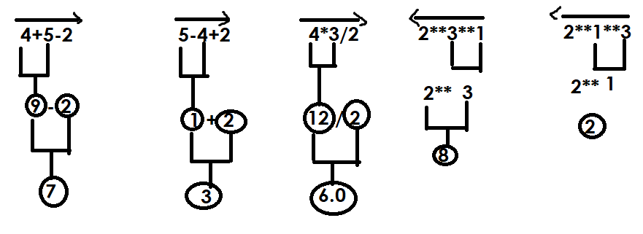
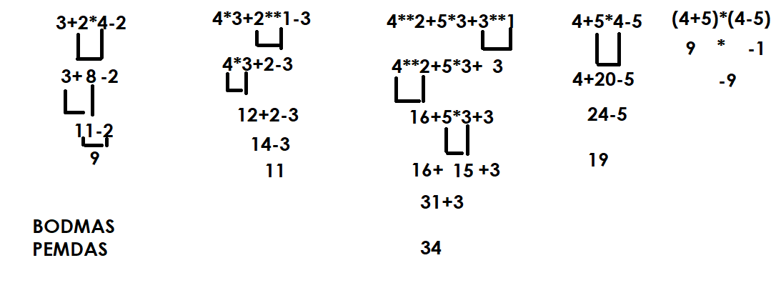

Relational Operations
These operators are used to for comparing values. The expression build using relational operators is called boolean expression. After evaluation of this expression it returns True or False.

Operators | Description
> | Greater than
< | Less than
>= | Greater than or equal
<= | Less than or equal
== | Equal
!= | Not Equal

All relational operators are binary operators and required 2 operands
Example:  r1=10>2  print(r1)  r2=10>=2  print(r2)  r3=10>=10  print(r3)  r4=10>=20  print(r4)  r5=10<20  print(r5)  r6=10<=20  print(r6)  r7=10<=10  print(r7)  r8=10<=5  print(r8)  r9=10<5  print(r9)  r10=10==10  print(r10)  r11=10==15  print(r11)  r12="nit"=="nit"  print(r12)  r13="nit"=="NIT"  print(r13)  r14=1==1.0  print(r14)  r15="nit"!="NIT"  print(r15)  r16="nit"!="nit"  print(r16) | Output  True  True  True  False  True  True  True  False  False  True  False  True  False  True  True  False
Example  res1=10>5>4  print(res1)  res2=10>5>20  print(res2)  res3=10>5<2  print(res3)  res4=10>5<20  print(res4)  n=5  res5=1<=n<=10  print(res5) | Output  True  False  False  True  True

Logical Operators
Logical operators are used for combining two or more boolean expressions.
In python logical operators are represented using 3 keywords
- and
- or
- not

and operator
Truth table of and operator
Opr1 | Opr2 | Opr1 and Opr2
True | True | True
False | False | False
False | True | False
True | False | False

Example:  a=True  b=False  c=True  r1=a and b  r2=b and c  r3=a and c  r4=b and b  print(r1,r2,r3,r4)  r6=10>5 and 10>20  print(r6)  r7=10>20 and 10>5  print(r7)  r8=10>5 and 10>9  print(r8)  #POC  r9=100 and 200  print(r9)  r10=100 and 0  print(r10)  r11=0 and 200  print(r11)  r12="A" and "B"  print(r12)  r13=100 and 200 and 300  print(r13)  r14=100 and 0 and 300  print(r14) | Output  False False True False  False  False  True  200  0  0  B  300  0

ord(), chr()

ord() function returns ascii value of given character
chr() function returns character value of given ascii value

>>> ord('A')
65
>>> ord('B')
66
>>> ord('a')
97
>>> ord('z')
122
>>> ord('Z')
90
>>> ord('0')
48
>>> ord('9')
57
>>> chr(65)
'A'
>>> chr(97)
'a'
>>> chr(90)
'Z'
>>> chr(122)
'z'
>>> chr(48)
'0'
>>> chr(57)
'9'

or operator

truth table of or operator
Opr1 | Opr2 | Opr1 or Opr2
True | True | True
False | True | True
True | False | True
False | False | False

Example:  a=True  b=False  c=True  r1=a or b  print(r1)  r2=b or c  print(r2)  r3=a or c  print(r3)  r4=b or b  print(r4)  r5=10>2 or 10>50  print(r5)  r6=10>20 or 10>5  print(r6)  # POC  r7=100 or 200  print(r7)  r8=0 or 200  print(r8)  r9=100 and 200  print(r9) | Output  True  True  True  False  True  True  100  200  200

not operator

It is a unary operator and required one operand to perform operation

Truth table
Opr1 | not opr1
True | False
False | True

Example:
>>> not True
False
>>> not False
True
>>> not 10>5
False
>>> not 10>20
True

Precedence of logical operators
- not
- and
- or

